|  |  |
| --- | --- |
| **Registration Form**  To be completed, one for *each* hound | |
| Owner’s name: | Hound's Name: |
| Address: | Breed: |
|  | Gender: |
|  | D.O.B. Month: Year: |
|  | Colour: |
| Email: | Neutered Yes/No *(please delete as appropriate)* |
| Tel: | Vaccinated Yes/No *proof of L4, DHP and KC required* |
| Mobile: | Vet Name: |
| Emergency Contact Name: | Vet Address: |
| Emergency Contact Tel: |  |
|  | Vet Tel: |
| Microchip No: | Tattoos: |
| **Feeding Instructions** (All food and any treats must be provided by the Owner): | |
| What do they eat: (Quantities) | |
| How often? | |
|  | |
|  | |
| **Exercise Routine**: | |
|  | |
|  | |
| **Regular Medication**: | |
|  | |
|  | |
|  | |
| Any other **Special Requirements**? Resource Guarding? Separation Anxiety? Etc. | |
|  | |
|  | |
|  | |
|  | |
|  | |
| Mark here to confirm you have read and agree  to the Terms and Conditions described overleaf. Signature …………………………… | |

***A Booking Form should be completed for each visit.***

**Terms and Conditions**

1. Dogs will NOT be walked off lead during a normal walk, *however we do have an option for dogs who do need a good run, to hire a secure, safe and private enclosure nearby to let off steam.*
2. Charges will be agreed prior to booking.
3. A deposit of 30% is taken at the time of booking and will be retained in the event of a cancellation by the customer within 14 days of the booked date. Booking will not be confirmed until the deposit is paid.
4. Full Balance is due prior to drop off.
5. It is a requirement of our licence that all dogs boarded with us MUST have full vaccinations including **Kennel Cough**.
6. Your emergency contact has permission to make decisions regarding the pet's health and is able to collect the dog should the need arise.
7. If neither you nor your emergency contact is contactable, you agree for the pet carer to make decisions regarding the pet's health providing that they are in the best interests of the animal, following the advice of a qualified vet. Upon your return, you agree to pay any vet bills incurred.
8. You agree to your dog(s) being homed with the household dogs.
9. We require a “meet and greet” prior to the dog’s stay, to ensure compatibility and non-aggression with the household dogs.
10. Please note we do not accept unneutered males, bitches in season or dogs under 6 months old for Home Boarding.
11. Booking deposits & payments should be made to our Bank Account:

Pamela Dormer Trading as Grey Stayz Home Boarding

Acc. No. 69666380 Sort Code: 60-83-71

We do not accept cheques.

**THANK YOU FOR USING Grey Stayz Home Boarding – Pam & Dave**

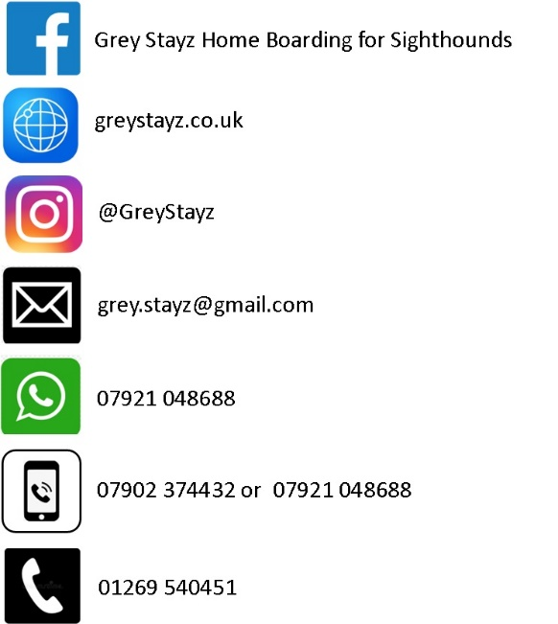

**Charges**

One Hound Boarding £30 per night

Second Hound £20 per night

Pick up after 12 noon £20 extra per dog

Day Care full day £30 each dog

Day Care half day £20 each dog

(Half day = up to 4 hrs)

Dog “Sitting” (Your home) & Pet Taxi

prices on request